**BIOL 121 Optional worksheet on species concepts and speciation**

There are four species of marmot in British Columbia. Marmots are the largest member of the squirrel family (Family Sciuridae). The Hoary Marmot (*Marmota caligata*) is found on the mainland in the coastal mountains. They are commonly referred to as ‘whistlers’ or “whistle-pigs’ because of their high pitched warning call. The town of Whistler gets its name from their call. The Vancouver Island Marmot (*Marmota vancouverensis)* is the only marmot found on Vancouver Island. The Vancouver Island marmots likely represent the descendants a small population of Hoary marmots that became isolated after sea levels rose at the end of the last ice age, approximately 6000 years ago.

The table below has information on the characteristics of both species.

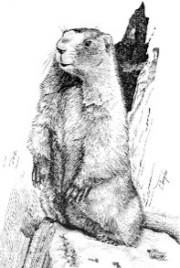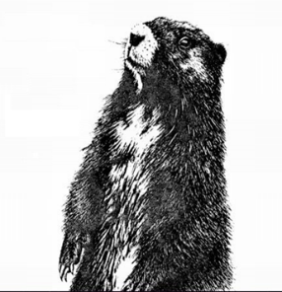

Vancouver Island Marmot (*Marmota vancouverensis*) Hoary Marmot (*Marmota caligatas*)

|  |  |  |
| --- | --- | --- |
| **Factor** | **Vancouver Island Marmot** | **Hoary Marmot** |
| Fur Colour | Chocolate Brown with white patches | Silver Gray |
| Weight | Up to 5 kg (adult) | Up to 10 kg (adult) |
| Length | Up to 47 cm (adult) | Up to 82 cm (adult) |
| Range | Vancouver Island | Coastal Mountains – Alaska to Washington |
| Habitat | High alpine meadows and rocky slopes | High alpine meadows and rocky slopes |
| Diet | Herbivore – eat plant material such as ferns, mosses, grasses, berries | Herbivore – eat plant material such as leaves, flowers, grasses, mosses, grasses and berries |
| Predators | Golden eagle, cougars, wolves | Golden eagles, bears, cougars, wolves, foxes, coyotes |

a. Which species concept (choose only one) would justify the classification of the Vancouver Island Marmot and the Hoary Marmot as one species? Explain your answer using only the information provided.

b. Under which species concept (choose one only) would Vancouver Island Marmots and Hoary Marmots be considered two different species? Explain your answer using only the information provided.

c. What specific evidence would a biologist need to determine that the Vancouver Island Marmot and the Hoary Marmot were different species using the phylogenetic species concept? Explain how this evidence would allow them to make their decision.

d. Describe the evolutionary steps that would result in the Vancouver Island Marmot populations and the Hoary Marmot populations becoming two distinct species. Explain what could happen during each step to cause this result. Use the biological species concept and include references to appropriate evolutionary mechanisms in your answer. Be as specific as possible.

|  |
| --- |
| Step 1 |
| Step 2 |
| Step 3 |